ELECTRODYNAMICS
MACHINES
There are various forms of rotating electrical machines. However, they can be divided into:
Generators – which convert mechanical energy into electrical energy. Based on the principle of Faraday’s Law of Electromagnetic Induction.
Motors – which convert electrical energy into mechanical energy. Based on the principle of Fleming’s Motor Rule.
- Both types operate through the interaction between a magnetic field and a set of windings (coils).
- A current- carrying conductor has a magnetic field induced around it.
- A magnetic field can cause an electric current i.e. a changing magnetic field can induce an emf, resulting in the flow of current. Such a current is called an induced current.
- The strength of the induced current increases when:
- the speed of movement of magnet relative to the coil increases
- the magnetic flux linkage is increased ( i.e. a stronger magnet)
- the number of turns increases
GENERATORS
Generators work on the principle of magnetic induction.
Faraday’s Law of Electromagnetic Induction: An emf is induced in a conductor when there is a change in the surrounding magnetic field. The magnitude of the induced emf is directly proportional to the rate of change of magnetic flux.
AC generators
The principle of rotating a conductor in a magnetic field is used in electrical generators. A generator converts mechanical energy into electrical energy.
The diagram below shows a simple generator:
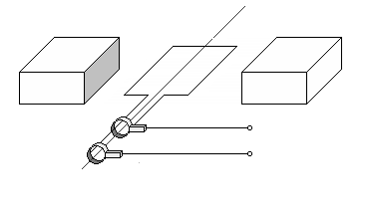
N
S
A
B
X
Y

N = North Pole magnet
S = South Pole magnet
A = slip ring commutators
B = carbon brushes
The coil is connected to slip ring commutators.
The commutators make contact with the carbon brushes, which ensures that the current can flow.
As the coil rotates in the magnetic field, it experiences an induced emf.
According to Fleming’s Right Hand Rule, an induced current will now flow.
The direction of the current changes with every half turn of the coil. This gives rise to alternating current.
DC generators
A simple DC generator is constructed in the same way as an AC generator except that the slip ring commutator is now replaced by a split ring commutator. The split ring commutator only allows current to flow in one direction.
MOTORS
Motors work on the principle of Fleming’s Left Hand Motor Rule.
DC motors
Motor converts electrical energy into mechanical energy.
The diagram below shows a simple diagram of a dc motor.
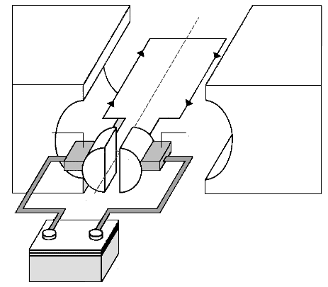
Direct current source
Split ring commutator
Brush
Brush
Rotation
N
S
+
-

- The split ring commutator serves as a change switch that reverses the current after every half revolution.
- The brushes maintain electrical contact between the battery and the turning commutator.
- The current in the coil flows through the magnetic field in the opposite direction.
- The coil will therefore turn clockwise until it is vertical.
- In the vertical position, the gaps between the commutator segments are bridged by the brushes and the current is therefore short-circuit for a moment through the commutator, and no current flows in the coil.
- The momentum of the coil carries it past this position.
- As soon as the coil passes the vertical position, each one of the brushes makes contact with the other commutator segment.
- The direction of the current in the coil is therefore reversed and the coil continues turning.
- After every half revolution the current through the coil is reversed and in this way the coil continues turning clockwise.
AC motors
An AC motor is very similar to a DC motor, except that the split ring commutator is replaced by a slip ring commutator and the current is now an alternating current and not a direct current.
Uses of AC generators
- To generate electricity at power stations
- Provision of electricity to equipment at construction sites
- Provision of electricity to businesses and industries
- Bicycle dynamo
Uses of DC generators
- Factories that do electroplating require huge amount of direct current
- In older vehicles DC generators are used to charge batteries to supply the vehicle with electricity
Uses of motors
Hairdryers, washing machines, household electrical equipment etc
Alternating current (AC)
An alternating current (AC) is a current that keeps changing direction backwards and forwards in a repetitive manner. The electricity supplied by Eskom is alternating current, it changes direction 50 times per second i.e.: it has a frequency of 50 Hz. It is important that this frequency is maintained to avoid damage to electrical equipment.
Alternating current, rather than direct current is used because electricity needs to be distributed through the country at a higher voltage to reduce unnecessary losses in the power cables. This is in order to be able to increase the voltages from the power stations and to reduce it again before it reaches the home.
Transformers must be used to step the voltage down in order to reduce the heating effect. Transformers make use of the concept of mutual induction and this can only work on alternating current. It is also easier to generate alternating current than direct current.
REMEMBER:
SPLIT RING COMMUTATOR = DC = direct current = current in one direction
SLIP RING COMMUTATOR = AC = alternating current = current changing direction every 180 degrees
The actual effect of the alternating current is less than the maximum value would suggest. So we work with values that represent the equivalent direct current values, also voltage and power.
Root mean square (abbreviated RMS or rms), also known as the quadratic mean, is a statistical measure of the magnitude of a varying quantity. The name comes from the fact that it is the square root of the mean of the squares of the values. The following formulae are used:

I_{rms} = and V_{rms} =

The average power in an AC circuit is given by P_{average} = V_{rms}I_{rms} =½ I_{max} V_{max} (for a purely resistive circuit).
The following graph shows the voltage vs time for an AC circuit:

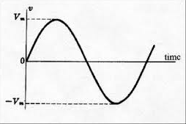

A similar graph can be drawn for the current vs time in an AC circuit:
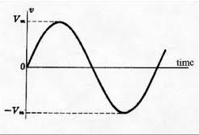
-I_{max}
I_{max}

QUESTION 1: DBE FEB/MARCH 2013

AC generators and DC generators differ in their construction and the type of current they deliver. The simplified sketch below represents a DC generator.
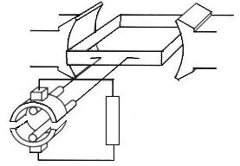

N S

P

Q

1.1 Which component (P or Q) enables this generator to produce DC? (1)
1.2 What structural change must be made to this generator to change it to an AC generator? (1)
1.3 Briefly explain why Eskom prefers using AC instead of DC for the long-
distance transmission of electricity. (2)
1.4 An AC generator delivers 240 V_{rms} to a 60 W light bulb. The peak current in the light bulb is 0,35 A.
Calculate the:
1.4.1 | rms current in the light bulb | (3)
1.4.2 | Resistance of the light bulb | (3)

QUESTION 2: DBE NOV 2012
The diagram below illustrates how electricity generated at a power station is transmitted to a substation.
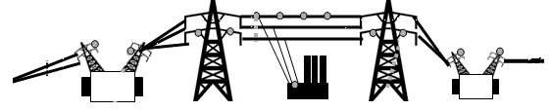
Power station
Step-up transformer
for long-distance transmission
Transmission lines
Substation

2.1 | Does the power station use an AC or a DC generator? (1)
2.2 | Sketch a graph of the potential difference generated at the power station versus time. (2)
2.3 | The average power produced at the power station is 4,45 x 10⁹ W.  Calculate the rms current in the transmission lines if the power is transmitted at a maximum voltage of 30 000 V. (5)
2.4 | Give a reason why electricity should be transmitted at high voltage and low current. (1)
QUESTION 3: DBE FEB/MAR 2011
AC generators at coal-fired power stations supply most of the electrical energy needed in our country.
3.1 | State ONE structural difference between an AC and a DC generator. (2)
A certain AC generator (alternator) produces a peak current (I_{max}) of 6,43A
when connected to an electrical heater of resistance 48,4 Ω.
3.2 | Calculate the rms current (I_{rms}) produced by the generator. (3)
3.3 | Calculate the peak voltage (V_{max}) output of the generator. (5)
3.4 | Draw a sketch graph of potential difference versus time for this AC generator. Clearly label the axes and indicate V_{max} on the potential difference axis. (2)
3.5 | To meet energy demands in the country, the government plans building nuclear power stations. State ONE environmental advantage of the generation of electricity in nuclear power stations over coal-fired power stations. (1)
QUESTION 4: DBE NOV 2010

The output of an AC generator is shown in the graph below.

311,13
- 311,13
time (s)
potential difference (V)

A light bulb with an average power rating of 100 W is connected to this generator.
4.1 | Calculate the following:
 | 4.1.1  4.1.2 | rms potential difference across the light bulb (3)  Peak current (I_{max}) through the light bulb (5)

QUESTION 2: DBE Nov 2009
One type of electric motor is a DC motor.

2.1  2.2 | Name the component, which ensures continuous rotation of the coil in a DC motor. (1)  Name the part of the motor, which becomes an electromagnet when the current flows in the motor. (1)
2.3 | When the electric motor is connected to a 12 V DC supply, it draws a current of 1,2 A. The motor is now used to lift an object of mass 1,6 kg through a vertical height of 0,8 m at constant speed in 3 s.  Is all the electrical energy converted to the gain in potential energy of the object? Support your answer with relevant calculations. (7)
QUESTION 1: DBE NOV 2008
A coil is rotated anti-clockwise in a uniform magnetic field. The diagram below shows the position at the instant the coil lies parallel to the magnetic field.

1.1 What type of generator is illustrated in the diagram? Give a reason for your answer. (2)
1.2 Determine the direction of the current in segment XY when the coil is in the position shown above. Only write down X to Y OR Y to X. (2)
Assume that the speed and direction of rotation are constant. Draw a sketch graph of potential difference against time that represents the output of this device. (2)

QUESTION 2: DBE 2010 MARCH
A simplified sketch of a generator is shown below.

2.1 Is the output voltage AC or DC? Give a reason for your answer. (2)
2.2 State TWO effects on the output voltage if the coil is made to turn faster. (2)
2.3 What is the position of the coil relative to the magnetic field when the output voltage is a maximum? (1)

QUESTION: DBE 2009 TRIAL
The simplified sketch drawn below shows the principle of operation of a generator.
Does the sketch show an AC or a DC generator? Provide evidence from the sketch to substantiate your answer. (2)
12.2 State whether the segment of the coil labelled PQ must be rotated clockwise or anticlockwise to produce the current in the direction as shown in the sketch. (2)
12.3 Describe TWO methods that could be implemented to improve the output of the generator shown in the sketch. (2)
12.4 Draw a labelled sketch graph of the induced emf versus time for the generator shown in the above sketch. (3)

QUESTION 11 GAUTENG SEPTEMBER 2015
A learner built the following simple generator based on a dynamo used to power bicycle headlights. He used the generator to demonstrate that he could use mechanical energy to generate electrical energy.
11.1 |  | Is this a DC or an AC generator? Give a reason for the answer. | (3)
11.2 |  | How will the learner know that electrical energy is produced? | (1)
11.3 |  | Explain how this generator is able to produce electrical current when there is no electrical connection between the rotating magnet and the copper coil. | (3)
11.4 |  | List TWO changes that can be made to the generator to INCREASE the BRIGHTNESS of the globe. | (2)
A generator (dynamo) used to power a light on a bicycle needs an average power of 6 W and a potential difference of 12 Vrms .
11.5 | Calculate the maximum current that can flow through the globe. | (4)

QUESTION 10 DBE JUNE 2015
10.1 | The output potential difference of an AC generator is 100 V at 20 Hz. A simplified diagram of the generator is shown below. The direction of the current in the coil is from a to b.
  10.1.1 | In which direction is the coil rotating? Write only CLOCKWISE or ANTICLOCKWISE. | (1)
10.1.2 |  | Starting from the position shown in the diagram, sketch a graph of the output potential difference versus time when the coil completes TWO full cycles. On the graph, clearly indicate the maximum potential difference (100 V) and the time taken to complete the two cycles. |  |  | (3)
10.1.3 |  | State ONE way in which this AC generator can be used to produce a lower output potential difference. |  | (1)
10.2 | An electrical device is rated 220 V, 1 500 W.

10.3 Calculate the maximum current output for the device when it is connected to a 220 V alternating current source. (5)

QUESTION 10 DBE FEB/MAR 2016
10.1 | A simplified sketch of an AC generator is shown below.
The coil of the generator rotates clockwise between the pole pieces of two magnets. At a particular instant, the current in the segment PQ has the direction shown above.

 |  | 10.1.1 |  | Identify the magnetic pole A.  Only write NORTH POLE or SOUTH POLE. |  | (1)
 | 10.1.2 |  |  |  | The coil is rotated through 180º.  Will the direction of the current in segment PQ be from P to Q or Q to P? | (1)
10.2 |  |  | An electrical device is connected to a generator which produces an rms potential difference of 220 V. The maximum current passing through the device is  8 A.

Calculate the:

10.2.1 | Resistance of the device | (5)

10.2.2 | Energy the device consumes in two hours | (5)

